Body language for page 1
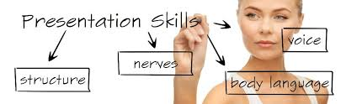

Presentation skills involve:
Speech structure - Your PowerPoint
Effect nerves - Preparation (thing that can go wrong)
Good voice
Body language

Practice in front of a mirror (or video). WHY? ----> To see your body language
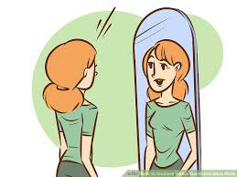

How important is body language? 55% - Body (people see you)
38% - Voice (people hear you)
7% - Words (listen & understand you)
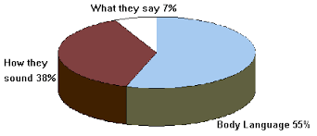

Your body language is important for confidence.
Confidence helps you be yourself. Remember authentic (being yourself).
In part - Authentic is achieved with open hands &
Power Pose gives you energy (enthusiasm).
If you have good energy then you have good PRESSENCE
People want to look and listen to you (captivating)

Your Body Communicates
Usually you do think about your body language page 2 Being confident & comfortable usually means good body language.

Personal grooming and confidence

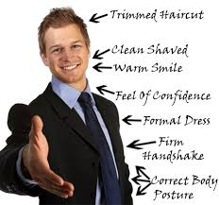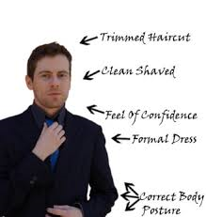

Before presenting, attention to personal details relaxes the mind
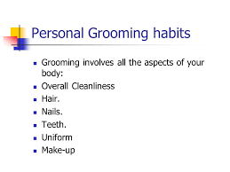

Attention to uniform, clothes

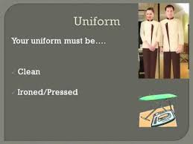

You are giving an impression – Be professional

DRESS WELL – GROOM WELL
BODY LANGUAGE EXAMPLES page 3

1)Which person would you listen to? 1) How are their bodies different?
A B
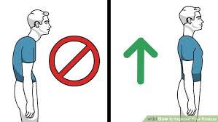

C Describe this body language below (both)? D Does this woman have good body language
Are they communicating well? Why or why not? (eyes, shoulders, gesture)
How do you know (3 or more ideas)? Anything else?

E & F) What are the positives in these two pictures? (The good body things in pictures E & F?)
Give more than one idea.

E F

G) What is woman ‘G’ doing with her body language? page 4

G H) Is this speaker comfortable/ How do you know?
(feet/legs, posture, arms)
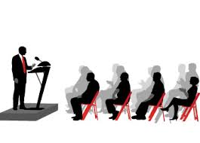

i, j, K, L) How are pictures i, j, K, L similar?

Would you listen to speakers H, i, j, K?

i) How are pictures i & j similar in body language? j

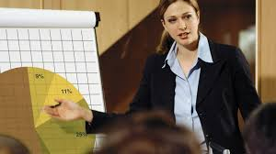

How are pictures K & L similar in body language? (at least 2 ideas)
K L

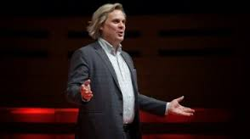

G, i, j, K, L) These people are making themselves big but not aggressive, how?
Do they have presence?
HOW WAS YOUR BODY LANGUAGE? (from your presentation) page 5

KINESICS: meanings of body motion
PROXEMICS: use of space (far away / close / lean towards or away)
HAPTICS: touch (hand sake, pat on back, ideas that touch the mind)

- Facial expression

1a) Did you smile?
1b) Did you change facial expressions?
1c) What expressions did you have?

2) Eye contact brings the audience in to the conversation.
RULES: look at individual people for a few words or a phrase. (slow)
- Move in ‘Z’.
- When you see a negative person –> Smile (make it into a game).
- Focus on + people.
- Use eye contact to pause, slow down, focus important ideas

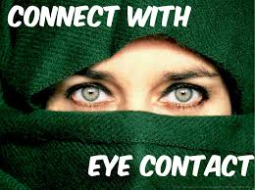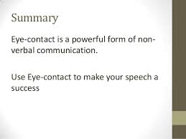

2 a) How often did you look at the audience?
2b) When you looked at the audience, did you look fast or slow?
2c) Did you look at any one person or just a general view?
2d) Did you read your slides? (a little/ a lot)
2e) Did you look down?
3) Gestures are used to draw attention to important ideas. page 6
- They make your presentation more interesting
- The open hand is great to communicate openness & trust
- Gestures such as the point, chop, count fingers, OK, thumbs-up, fist for force can work with the presentation.
AUDIENCE has body language - Use it
YOU smile at him focus on + people
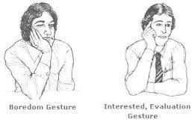

3 a) Were your hands open or closed?
3b) Did you point things out on the slide?
3c) What gestures did you use?
3d) Did you do any type of power pose (make yourself big)?

4 POSTURE Ears behind shoulders - have a straight but relaxed look
- Arms should be relaxed next to body ready to be used for a gesture.
- Feet shoulder distance apart
4a) Was your posture good?

Posture is relaxed but straight Do not be afraid to use space
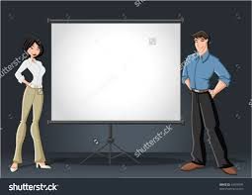

5 SPACE - use your space
Unless you have a podium - move.
5a) Did you stand still / Did you move a little or a lot?
5b) If you moved where did you move to?
5c) At any time did you move or lean towards the audience?
5d) Did you organize your movement with your presentation?

