Unit 2 Passenger terminal environment

Airport

An airport is a designated location where aircraft take off and landing. They provide the entire infrastructure needed for passengers to transfer from surface modes of transport to the air mode of transport and carry freight by air. In terms of commercial aviation, airports may be classified into two categories; Domestic and International
Domestic airport handles only flights within the same country.
International airport handles international departure and arrival flights- though many international airports often host both domestic and international flights.
Airport Geography
The airport terminal may be divided vertically and horizontally into four areas;
- Landside
- Airside
- Departure
- Arrival

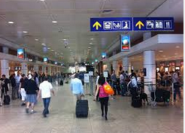

Landside

The landside area of the terminal starts from the entrance of the airport and ends at security and immigration (international airports). The landside area consists of check-in counters or kiosks, baggage drop-offs, restaurants, and shops.

Airside 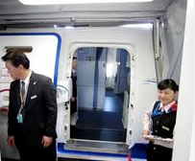
The airside covers the area from security and immigration to the airplane door. The airside area consists of waiting areas near the gates, lounges, shops, and restaurants. The airside of the terminal is strictly restricted to individuals with proper documents such as boarding passes or airport permits. Anyone entering the airside area must be screened by the airport security.

Departure

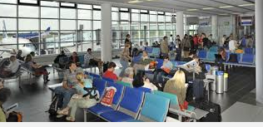
The departure area consists of check-in counters, shops, restaurants, immigration, security, waiting areas, and gates.

Arrival
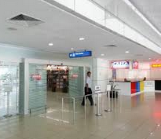
Once the passengers reach their destination, they will disembark from the aircraft and proceed to the arrival area within the airport terminal.

Based on the different geographical locations, these areas are also combined into the following; landside departure, landside arrival, airside departure and airside arrival

Landside Departure
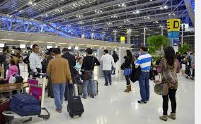
The landside departure area is accessible to both travelers and non-travelers. Check-in counters are located in this area and often include special counters dedicated to first and business class passengers, ticket sales offices, restaurants, shops, airport information booth, public telephones, and public toilets.

Airside Departure

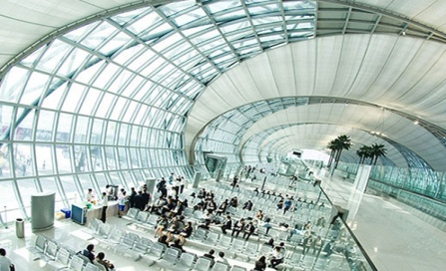
The airside departure area is accessible only to passengers with valid travel documents. Facilities located in this area include immigration counters, X-ray machines for security screening, duty free shops and departure gates. Major airlines may provide lounges for their first class, business class, and frequent flyer customers.

Airside Arrival

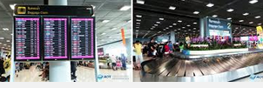
This area begins the moment the passengers disembark from the aircraft to the location where they collect their baggage. It includes transfer check-in counters, security, and immigration (for international terminals).

Landside Arrival

This is the greeting area for arriving passengers. Facilities such as banks, ground transportation services, hotel information desks, and local tourism information desks or kiosks are located in this area.

Airport facilities

Flight information display system (FIDS)
Fids may located at check-in counter or boarding gate .It displays in the form of electronic display board or TV screens .Today many airports display on the airport’s web-site. Information displayed on FIDS includes
-Airline name, logo, its International Air Transport Association (IATA) or its Civil Aviation Organization (ICAO) airline designator.
-City of origin or destination and any intermediate points.
-Expected arrival or departure time or the updated time in the event of delays.
-Gate number.
-Check-in counter number
-Status of the flight, such as” Landed”, “delayed”“Boarding” or “Cancelled”.
-The belt where baggage can be retrieved

Left luggage
This service provides for passengers who want to deposit their luggage for a period of time.
There are 2 forms of left luggage services; left luggage counter and a coin operated or automated locker systems.

Unaccompanied baggage service
Services for passengers who want to ship their excess baggage at a lower rate as compare to airline excess baggage charges. Operated by shipping company or airlines .The baggage will be sent to the designated airport.

Airport Ground Services

It is defined as the servicing of an aircraft while it is on ground and parking at terminal gate/apron of an airport including servicing of passengers and their baggage.
There are 8 major categories of ground services based on Annex A of the IATA standard handling agreement
1 Representation, Administration and Supervision
2 Passenger Services including Departure, Arrival, Remote/Off Airport Services, Inter-model Transportation by Rail, Road or Sea Section
3 Ramp Services including Baggage handling, Parking, Loading and Unloading, Safety measures, Moving of aircraft , Exterior Cleaning, Interior Cleaning , Toilet Service etc.
4 Load Control, Communications and Flight Operations
5 Cargo and Mail Services is Cargo and Mail Handling
6 Support Services; Accommodation, Automation/Computer Systems, Unit Load Device (ULD), Ramp Fueling
7 Security includes Passenger and Baggage Screening and Reconciliation, Cargo and Post Office Mail, Catering
8 Aircraft maintenance; Routine /non routine Services, Replenishing of Oils and Fluids, Material Handling, Parking and Hangar Space
In the airport terminal, there are allocated different duty locations according to their responsibilities
Check-in counter
Check-in counters are located at the landside concourse in the passenger terminal. Passengers proceed to the check-in counter where the airline ground staff issues their boarding passes and accepts their baggage. Each airline with scheduled flights at the airport is assigned check-in counters, which can be managed either by their own ground staff or through a handling company, such as a local airline.
Apart from check-in counters, passengers may also obtain their boarding pass through self-check-in services.
Nowadays, passengers can check-in online via the airline’s website on their computers or through mobile phones by themselves.
Passengers with bags can go direct to a bag drop off counter where the agent weighs the baggage before putting the travel itinerary label or baggage tag on the bag.
Check in counter may locate outside the airport terminal in the curb area. Upon arrival passenger can get boarding pass as soon as they arrive the airport this service will charge for extra charge but they may avoid the long queues in the terminal. Large city provides check-in at the public transport station and hotels with links to the airport. This is known as an off-site check-in. Hong Kong offer an off- site check-in at the transportation link terminals.

Airport ticketing
Airlines also provide ticketing sales services within the airport terminal. The ticketing office provides reservation and ticketing-related services to the passengers. With the ease of using electronic tickets today, many airlines have closed their city offices, due to ticketing issues resolved through the internet or the call center. Airport ticketing is also a point of sales where passengers require an immediate purchase of tickets and other cash handling activities such as paying excess baggage fees.

Boarding gate
The boarding gate is where passengers turn in their boarding passes and proceed to board the aircraft. It is located within the airside departure area after the security and immigration section. The main duties for the GSA at the boarding gate are
- check the passenger’s identification
- collect the passengers boarding pass
- make boarding announcements,
- keep passengers updated of the flight status.
- print out the flight manifest for the flight attendants before the flight is ready for departure. The GSA must determine that all passengers with boarding passes are on the plane and if not, arrange for the removal of checked-in baggage belonging to the missing passengers.

If the aircraft is assigned to park at the terminal, there will be a jet bridge connecting the terminal to the aircraft. On the other hand, when the aircraft is parked at a remote bay, passengers are connected by ground transportation, normally via buses to and from the terminal to the aircraft parking area, some small airport allow passengers to walk from the terminal and board the aircraft via the apron.

Waiting area
Depend on the design of the airport. New airports usually have a gate area with seating located next to the departure gate or an enclosed waiting area designated for flights as for smooth and quickly boarding.

Airline and Airport Lounge
Located in the airside area, different airlines provide different facilities within their lounges, which might include meals or snacks, beverages, meeting rooms, reading materials, shower rooms, and internet services.
The primary responsibilities for GSA in the lounge include answering general enquiries, resolving reservation issues, and handling reconfirmations for upcoming flights or for seating assignments or special requests.
Airline lounges today are often shared by different airlines so that they are in a better position to maximize their resources, such as One world and Star Alliances.

Arrival
Arrival hall is a location that the passengers enter after disembarked. The main responsibilities for GSA to prepare for the arrival passengers are
-notifying passengers of new travel information
-providing assistance to passengers who have connecting flights
-handling reserved wheelchairs
-providing baggage carousel information
-guiding the flow of passengers.

Transfer counter
This counter is similar to a check-in counter but it located within the arrival airside area. The counter provides check-in service to passengers who have connections flight but don’t hold an onward boarding pass. This check-in service helps connecting passengers to get checked-in at the airside area without having to go through customs, immigration, and quarantine for checking in check-in concourse. No baggage acceptance facility is available at the transfer counter.
GSA are required to review the passengers’ baggage claim receipts to ensure that the passengers’ checked baggage are tagged to the final destinations before they are allowed to board the aircraft.

Lost and found
The lost and found department is located in the baggage carousel or baggage claim area. Usually, there is an office or a counter for passengers to report lost bags. It is the airline responsible for lost bags. The responsibilities for the GSA are
- helping passengers to fill out the ‘tracing and locating lost baggage’ form
- returning lost baggage to the passengers
- settling lost baggage compensation claims
- arranging baggage repair if the baggage was damaged while under the custody of the airline.

Weight and balance
The responsibilities of the department are to ensure that the aircraft’s weight is below the maximum allowable weight and that it is evenly distributed. Weight and balance plays an important role for flight operations, ensuring that the aircraft is not overweight. This assists pilots to prepare the flight plan and ensures that the aircraft has sufficient fuel for the journey.

Load control
The responsibility of the department is to prepare flights for check-in. Load control duties are
- editing of flights one day prior to departure to provide seating arrangements for groups who have not had their seats pre-assigned.

- contacting the catering department or catering company to order meals for all passengers on board a flight, including those with special dietary requests.
-other services, such as Oxygen for a passenger with a documented medical need, are required on the flight. It is the load control office’s responsibility to contact the mechanical department to arrange for the necessary setup to be installed for the flight on the following day.

Example of Baggage Lost and Found Form

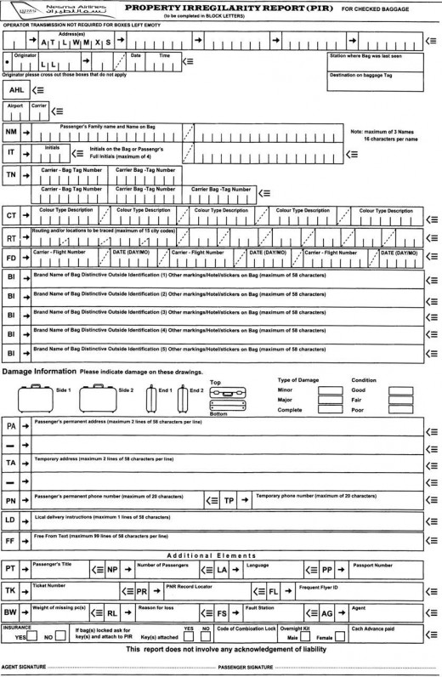

Interacting with Airport partner services

All organizations within the airport terminal work together to provide assistance to all airport users such as;

Airport authority
The airport authority is a management organization that manages an airport. This authority is responsible for the operation and maintenance of all the facilities within the airport terminal. GSAs are communicate with the airport authority department such as issuing extra counter rental due to high travel demand and baggage carousel changes.

Immigration
The main duty of immigration at an airport is to control the movements of citizens and visitors into and out of the country. This is the area where the passengers are required to present their passports for document checks and have their passports stamped with the arrival or departure date.
Immigration officers have the authority to refuse a passenger entry to or exit from a country. Immigration counters are located on both the departure and arrival levels of international airports.
GSA communicates with immigration officers regarding passengers who do not hold proper documents to enter the country. In the event that a passenger is refused entry, airline agents are required to assist him or her to return to the original country.

Customs
An airport is a ‘port’ or border where governments are concerned with controlling the inflow and outflow of goods in terms of both safety and collection of duty fees. The responsibility to the customs department whereby all baggage arriving at international airports are required to go through customs. The customs area is located at the airside area after the baggage carousel, before the passengers head out to the meeting area. GSAs often communicate with customs regarding passengers delayed bags. It is the GSAs responsibility to clear customs on behalf of the passengers who are not available for the customs clearance process.

Airport security
This department is responsible for screening passengers as well as airline and airport personnel and their belongings before they enter into the restricted area of the terminal building. This is always located at the intersection between the airside and landside in the departure area. The airport security is also located at the airside arrival area where transferring passengers are required to proceed after receiving their boarding passes at the transfer counter.

Law enforcement
Usually the police- is responsible for ensuring the safety of all airport users and airport property. Law enforcement is to be contacted when
-there is a threat to passengers, staff, or airport property
-the instances of flight-related incidents that involve dealing with any passenger whose behavior cannot be controlled or who is breaking any law.

Airport clinic
On-the-spot medical treatment services are provided at the airport clinic. The clinics are located within the airport terminal for sick or injured passengers or staff who required immediate medical attention.

Tax refund office
Value-added tax (VAT) is a form of consumption tax that the taxation office of the country collects when purchase is made. Many governments offer tax refund programs to motivate tourist purchases.

Embassy and consulates
GSAs may need to interact with representatives of an embassy regarding documentation issues: passport visa and other documentation.

Cooperation among airlines
The most common interaction concerns tight connections when an arriving flight is delayed. A delay may cause passengers to become ‘tight connection passengers’ which means that the time for the passenger’s connection falls below the minimum connecting time at an airport. Airlines sometimes wait for these late connecting passengers especially for large groups of travelers and very important persons (VIPs) at their own Hub. Therefore, the agents of these arrival airlines must communicate with the airlines to inform them of the situation including the arrival time, number of passengers, and the amount of baggage. They must deal with relocating the passengers on another flight and handling their checked baggage. If the passengers are forced to spend the night in the connecting city, the agent from the first airlines must find a hotel and provide vouchers for meal and accommodation.
Another type of interaction concerns occurs when airline cancel a flight so GSA are required to contact other airlines which has the same route and available seats.
Also concerns passengers who are issued a set of tickets to travel with different airlines. All issues pertaining to the ticket are to be directed to the ticket issuing airline, which requires interaction between different airlines’ employees. The respective agents must also work with representatives from the issuing airline to resolve any issues encountered.

Summary
The airport terminal is divided into different areas .The landside departure area is where departing passengers check-in for their flights before proceeding to the airside departure area to board their flights at the gate. Upon arrival, passengers disembark from the aircraft at the airside arrival area. Transit and transfer passengers continue their journey by returning to the airside departure to board their flights while arriving passengers proceed to the landside arrival area.

KEYTERM

AIRPORT is a location where aircraft take off and landing. It provides the entire infrastructure needed to enable passengers to transfer from surface mode to air modes transport
LANDSIDE AREA start from entrance of the airport to security and immigration, for arrival start from baggage claim to the airport exit

Airside of the terminal is the area from security to airplane door and arrival start from airplane door to baggage claim
Flight display system FIDS provides flight information to airport users, information is displayed either on electronic display boards or television screen
Check-in counter is located at the landside concourse in the passenger terminal of an airport. It is the location where passengers receive their boarding pass
Boarding gate is a location where passengers turn in their boarding passes and are allowed to board an aircraft

References:
Colin C. Law and Mary R. Doerflein (2014) Introduction to Airline Ground Service. Cengage Learning Asia Pte.Ltd. Singapore.
International Aviation Training Program. (2012). Introduction to the Airline Industry. Canada: International Air Transport Association: Author.
http://s2.hubimg.com/u/7565827_f520.jpg

