Introduction to Small Business
Definition of Small Business
Small businesses are privately owned corporations, partnerships, or sole proprietorships that have fewer employees and/or less annual revenue than a regular-sized business or corporation. Businesses are defined as “small” in terms of being able to apply for government support and qualify for preferential tax policy varies depending on the country and industry. In Thailand small businesses have been called together with medium businesses as Small and Medium Enterprises (SMEs). SMEs make up 98.5% of businesses in Thailand and account for some 70% of national employment, which is higher than the global average of 70%. SMEs contribute to about 30% of total exports from Thailand. SMEs feature prominently in the government’s strategy to stimulate growth and development. The food and agricultural industry remain a place to invest in 2016. It is a crucial contributor to the national economy and offers a wide diversity of agricultural commodities and processed food items. Blessed with an abundance of natural resources, a year-round growing season, a skilled, well-educated workforce, and relatively low labor costs, Thailand possesses significant competitive advantages in the food and agricultural arena.
Table I Definition of SMEs
Sizes | Industry | Long-term Assets (Million Baht) | Employees (person)
Small businesses | Manufacturing  Wholesaling  Retailing  Service | Less than 50  Less than 50  Less than 30  Less than 50 | Less than 50  Less than 25  Less than 15  Less than 50
Medium businesses | Manufacturing  Wholesaling  Retailing  Service | 50-200  50-100  30-60  50-200 | 51-200  26-50  16-30  51-200
Source: Office of SMEs Promotion, 2012 (p.36).

SMEs Internationalization
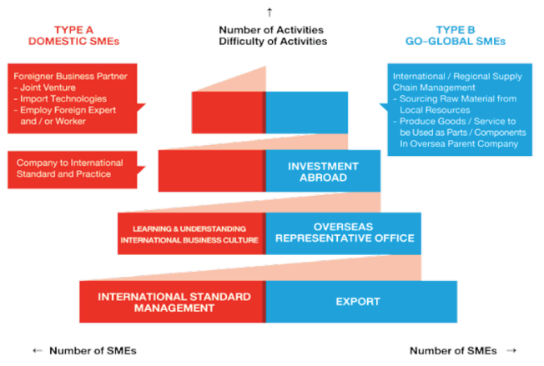
Source: Office of SMEs Promotion, 2012 (p.37)

