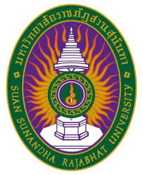

**Report Form for Seminar**

**Faculty of Airline Business, International College,**

**Suan Sunandha Rajabhat University**

**1. Personal Information**

**Name-Surname** ………**Nisara Paethrangsi……….Position**……….**Lecturer…….**

**Category**  ☑ Academic Staff □ Supporting Staff

**2. Curriculum/ Topics of the Meeting/ Workshop/ Study Visit**

**Team building, CV writing and personal development**

**3. Keynote Speaker in Meeting / Seminar/ Conference/** **Study Visit**

**1. B.H.M.S guest speaker**

**4. Institute or Corporate hosted of the Meeting / Seminar/ Conference/** **Study Visit**

**Business & Hotel Management School**

**5. Duration of the Meeting / Seminar/ Conference/** **Study Visit**

**December 11, 2018**

**6. Budget use for Meeting / Seminar/ Conference/** **Study Visit**

**SSRU yearly personal development budget**

**7. Objectives of Meeting / Seminar/ Conference/** **Study Visit**

1. **Discover effective ways to get tasks accomplished through team working.**
2. **How motivating a positive attitude, commitment to the team, trust, and communication can lead to phenomenal results.**

**8. Conclusion from Meeting / Seminar/ Conference/** **Study Visit**

**The Business & Hotel Management School held workshop in Teambuilding and Personal Development which divided the contents into 3 parts,**

**1 Teambuilding and personal development – Speaker Encourage innovation, experimentation and allow for freedom of engagement, dialogue, different voices to be heard. Gave guild line to activities and showed the importance of communicating ideas and experiences among the group to accomplish goals.**

**2. CV writing - Checklist on what to include in a CV. Stand out. Your CV should demonstrate your unique blend of skills and experience. Keep it simple. Your choice of font and layout is key to making sure a would-be employer carries on reading CV.**

**3. Table manners etiquette - rules of dining etiquette, the basics table manners, handling utensils, napkin etiquette, when to start eating.**

**9. Problem and issues of the Meeting /Seminar/ Conference/** **Study Visit**

**No**

**10. Benefit from Meeting /Seminar/ Conference/** **Study Visit**

* **To Yourself**
  1. **Discover how to break down communication barriers.**
  2. **Learn guidelines for keeping the team focused on productive planning**
* **To the College/ Institution**

1. **Discover the importance of communicating ideas and experiences among the group to accomplish goals and give suggestion to student when working in team.**
2. **Understand dynamics in conflict - and where you fit in as a mediator and work well with others**

**11. Handouts or Important Documents related to Meeting /Seminar/ Conference/** **Study Visit**

1. **Agenda of training**
2. **Slide and handouts**
3. **Activity Pictures**

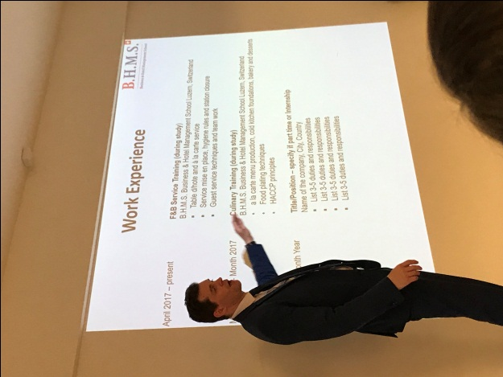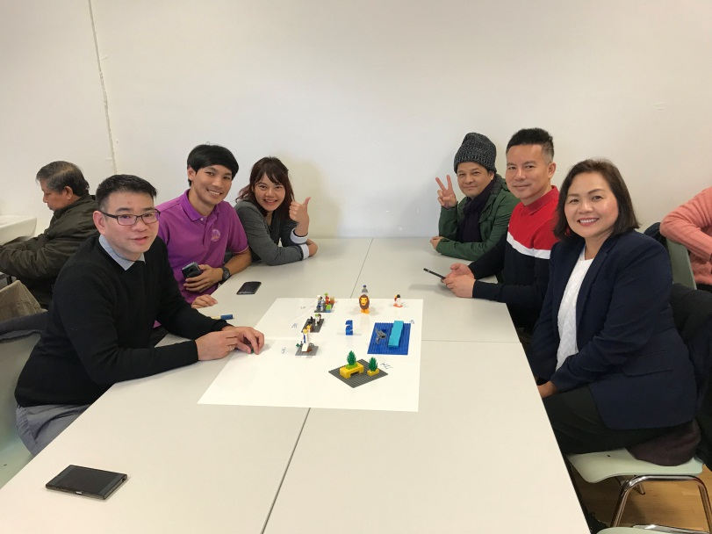

**12. Certificate of the Meeting /Seminar/ Conference/** **Study Visit**

**Yes**

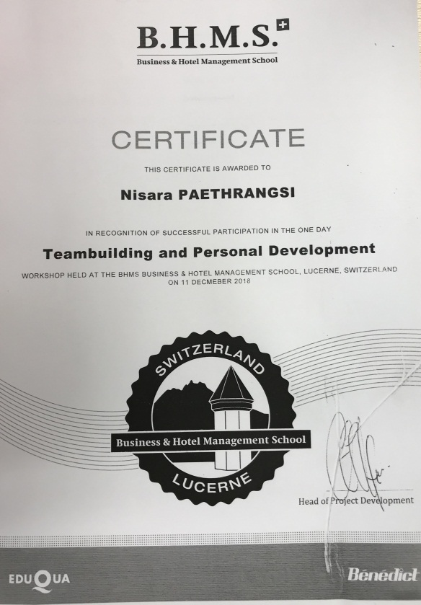

**13. Recommendations and Suggestion**

**That is an excellent training, I got knowledge in management development and self-development, communication skills, brainstorming innovative breakthroughs and assessment how each team member approaches their work and what that means for reducing conflict and increasing cooperation.**

**(Reporter).....................................................**

**(Aj. Nisara Paethrangsi)**

**Date February 4, 2019**

**Comments from the Superior**

...........................................................................................................................................................................

...........................................................................................................................................................................

...........................................................................................................................................................................

...........................................................................................................................................................................

**(Name)......................................................**

**(Aj.Theppaluk Komolvanij)**

**Date ..............................................................**