**TQF 3**

 Bachelor’s Degree



 Master’s Degree

**TQF. 3 Course Syllabus**

**Course Title:** **IGL1104**

**Course Title**: English Composition for Business

**Credits:** 3 (3-0-6)

**Program:** Tourism Management,

International College, Suan Sunandha Rajabhat University (SSRUIC)

**Semester:** 2  **Academic Year:** 2560

**Content**

**Section Pages**

**Section 1 General Information**  2

**Section 2 Aims and Objective** 3

**Section 3 Course Structure** 5

**Section 4 Developing Student’s Learning Outcomes** 6

**Section 5 Scheme of Work** 9

**Section 6 Learning and Teaching Resources** 14

**Section 7 Course Evaluation and Improvement** 15

**Section 1 General Information**

**1. Codes and Course Title:**

Course Code: IGL1104

Course Title (English): English **Composition for Business**

**2. Credits:** 3(3-0-6)

**3. Curriculum and Course Category:**

3.1 Curriculum: Bachelor of Arts in Tourism Managment (English Program)

3.2 Course Category:

General Education Required Course

Elective Course Others …………

**4. Lecturer Responsible for Course and Instructional Course Lecturer (s) :**

4.1 Lecturer Responsible for Course: Mr Robert Henry Heathfield

4.2 Instructional Course Lecturer(s): (1) Mr Robert Henry Heathfield

**5. Contact/Get in Touch**

Room Number: 304 Tel. 0923812178 E-mail: robheathfield1975@gmail.com

**6. Semester/ Year of Study**

6.1 Semester: 2 Year of Study: 2560 / 2017

6.2 Number of the Students enrolled: 34 students

**7. Prerequisite Course**

Course Code: ……………….. ICL1101……………..

**8. Co-requisite Course:** (If any)

Course Code: None

**9. Learning Location**

Nakhon Pathom Learning Center

**9. Last Date for Preparing and Revising this Course:**

**Date:** 8/1/18

**Section 2 Aims and Objectives**

**Course Aim**

The course aims at helping learners to achieve an overall English language proficiency of Basic User defined as A2 level on the Common European Framework of Reference for Languages (CEFR), developing social language functions such as greeting people, asking about work and free time, and making invitations.

**Course Objectives**

The course is intended to accomplish its goal through developing students’ language skills to:

1. Read and understand Elementary and Pre-intermediate texts and a range of high frequency vocabulary in context.
2. Talk about aspects of personal and everyday life, using appropriate stress, intonation, and rhythm, and understand simple, spoken texts on familiar topics.
3. Write simple cohesive paragraphs on familiar topics.
4. Demonstrate some control of essential grammatical structures with occasional inconsistencies.

**New Headway Elementary -** Key Features

Clear, structured approach to grammar with structures introduced in context, and questions that encourage students to work out the rules for themselves.

A comprehensive 'Grammar section' at the back of the Student's Books provides a useful reference before, during or after the lesson.

A well-defined vocabulary syllabus concentrates on three key areas: learning new words in lexical sets; acquiring good habits for learning vocabulary; and developing vocabulary 'systems' such as sound and spelling relationships.

Additional Information

Integrated skills work with the reading and listening activities in every unit contextualizing and bringing together previously introduced language.

The unit-by-unit writing sections in the Student's Books help to develop students' written English in a range of situations and registers.

Supportive Teacher's Books at each level include an explanation of the methodology, step-by-step lesson guidance, additional activities, photocopiable tests, cultural notes, and detailed answer keys.

**International Business English**

**Market Leader Pre-intermediate Third Edition**

TEACH STUDENTS REAL ENGLISH IN A BUSINESS ENVIRONMENT

Financial Times articles and practice exercises help students develop English for business.

Topics such as buying and selling, mergers and acquisitions, people skills, marketing and human resources expose students to the practicalities of business.

Consultant case studies help students learn general business practices while improving their English.

**Section 3 Course Structure**

**1. Course Outline**

English for Communication and Study Skills present real life situations and in which the language used is correct, authentic and actual.

- The Listening section invites students to listen to a real dialogue, and answer questions on it to make sure they fully understand what is happening.

- The Writing section explores how to use key expressions in English.

- The Speaking section provides practice to make students confident of using the key expressions correctly.

- The Reading and Vocabulary sections help students to consolidate and build on the language they learn.

**2. Time Length per Semester (Lecture – hours / Practice – hours / Self Study – Hours)**

|  |  |  |  |
| --- | --- | --- | --- |
| **Lecture**  (hours) | **Remedial Class**  (hours) | **Practice/**  **Field Work/Internship**  (hours) | **Self - Study**  (hours) |
| 48 | 48 | 0 | 16 |

**3. Time Length per Week for Individual Academic Consulting and Guidance**

3.1 Self-consulting at the lecturer’s office: Room Number 304, SSRUIC Building (Nakhon Pathom Education Center)

3.2 Consulting via office telephone/mobile phone: 0923812178

3.3 Consulting via E-mail: [robheathfield1975@gmail.com](mailto:robheathfield1975@gmail.com)

3.4 Consulting via Social Media: Line ID robheathfield1975

3.5 Consulting via Computer Network

**Section 4 Developing Student’s Learning Outcomes**

**1. Morals and Ethics**

1.1 Morals and Ethics to be developed

* (1) Teamwork
* (2) Manners
* (3) Personal Behavior

1.2 Teaching Strategies

* (1) Cooperative Learning
* (2) Conversation
* (3) Case Study

1.3 Assessment Strategies

* (1) Examination
* (2) Classroom Activity
* (3) Observation

**2. Knowledge**

2.1 Knowledge to be developed

* (1) English Vocabulary for International Business
* (2) Listening Skill for International Business
* (3) Reading Skill for International Business
* (4) Presentation for International Business

2.2 Teaching Strategies

* (1) Cooperative Learning
* (2) Role play
* (3) Practice

2.3 Assessment Strategies

* (1) Examination
* (2) Classroom Activity
* (3) Assignment

**3. Cognitive Skills**

2.1 Cognitive skills to be developed

* (1) English Proficiency
* (2) Planning and Organizing Skill
* (3) Initiative Skill

2.2 Teaching Strategies

* (1) Cooperative Learning
* (2) Role play
* (3) Practice

2.3 Assessment Strategies

* (1) Examination
* (2) Classroom Activity
* (3) Assignment

**4. Interpersonal Skill and Responsibilities**

2.1 Interpersonal Skill and Responsibilities to be developed

* (1) Social Manner
* (2) Customer Service Skill
* (3) Personality Development

2.2 Teaching Strategies

* (1) Cooperative Learning
* (2) Role play
* (3) Practice

2.3 Assessment Strategies

* (1) Examination
* (2) Classroom Activity
* (3) Assignment

**5. Numerical Analysis, Communication and Information Technology Skills**

2.1 Numerical Analysis, Communication and Information Technology Skills to be developed

* (1) English communication skill
* (2) Translation skill
* (3) Grammar Usage

2.2 Teaching Strategies

* (1) Cooperative Learning
* (2) Role play
* (3) Practice

2.3 Assessment Strategies

* (1) Examination
* (2) Classroom Activity
* (3) Assignment

**Section 5 Scheme of work and Assessment**

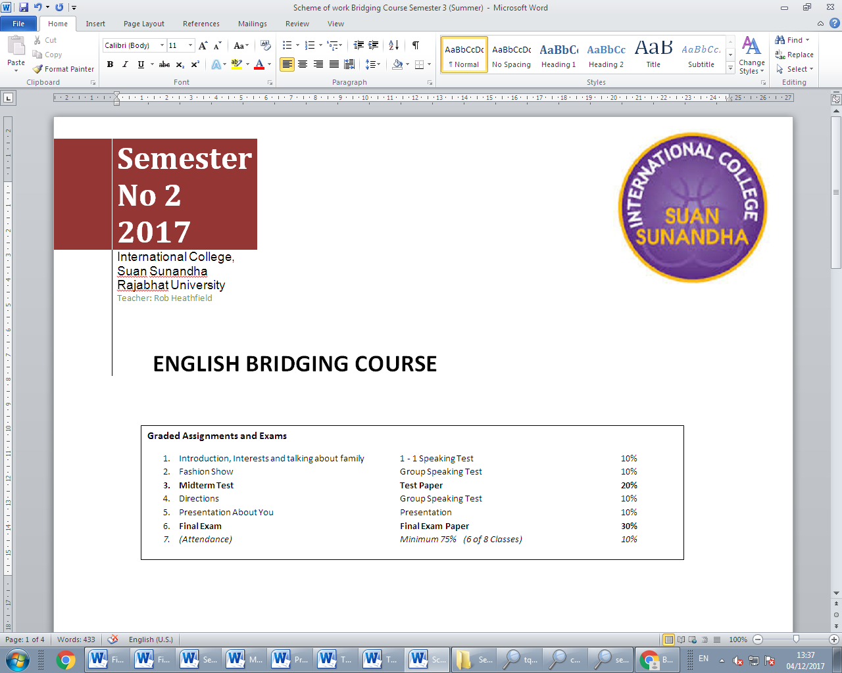

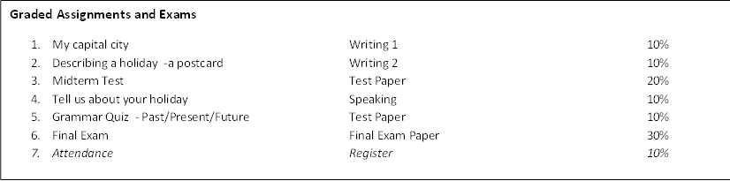

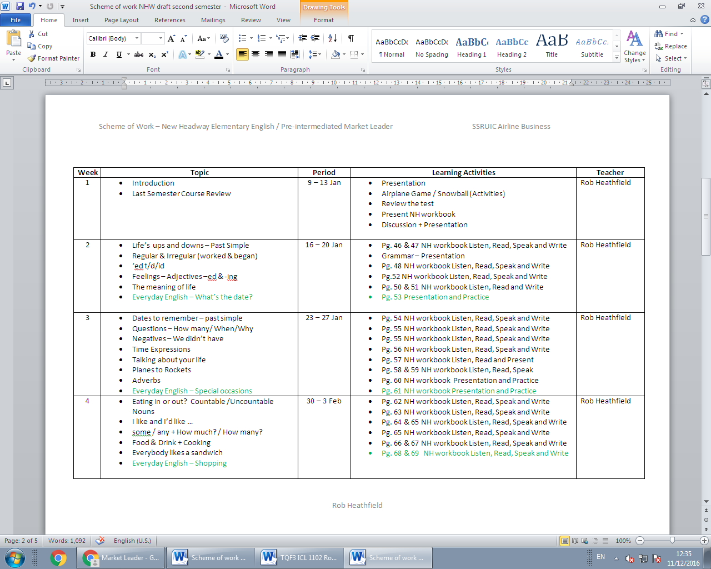

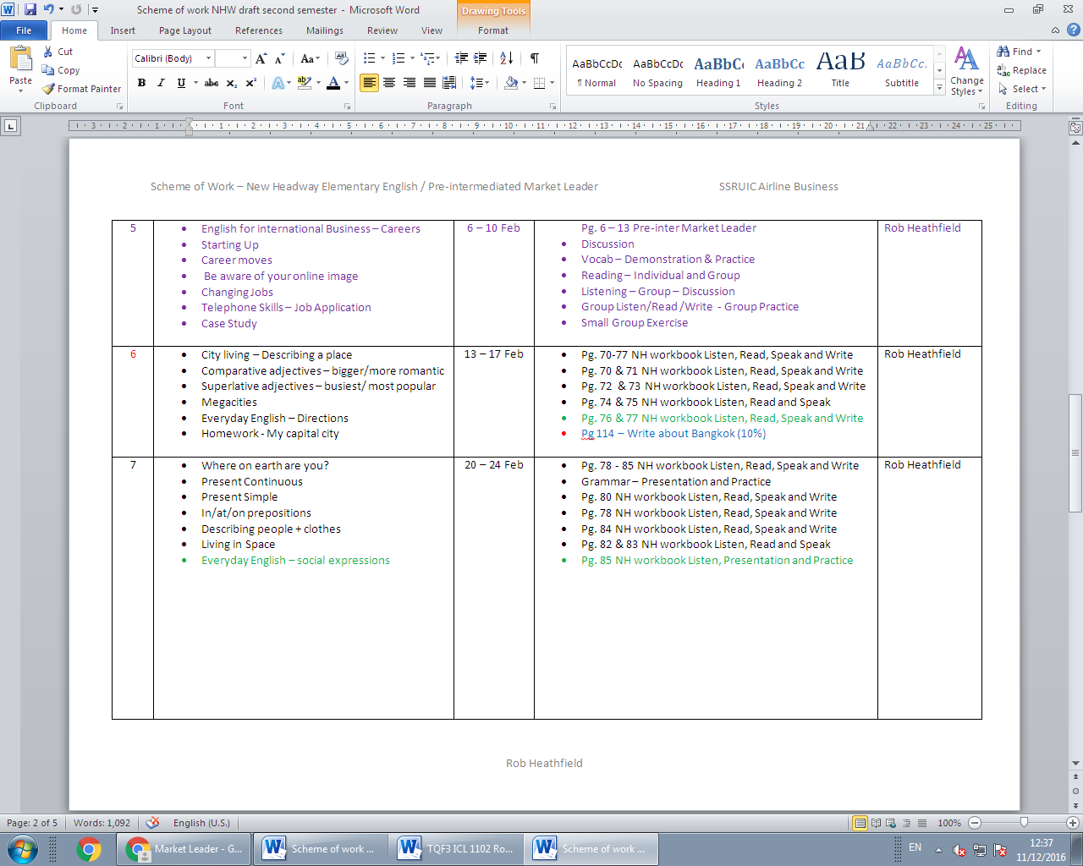

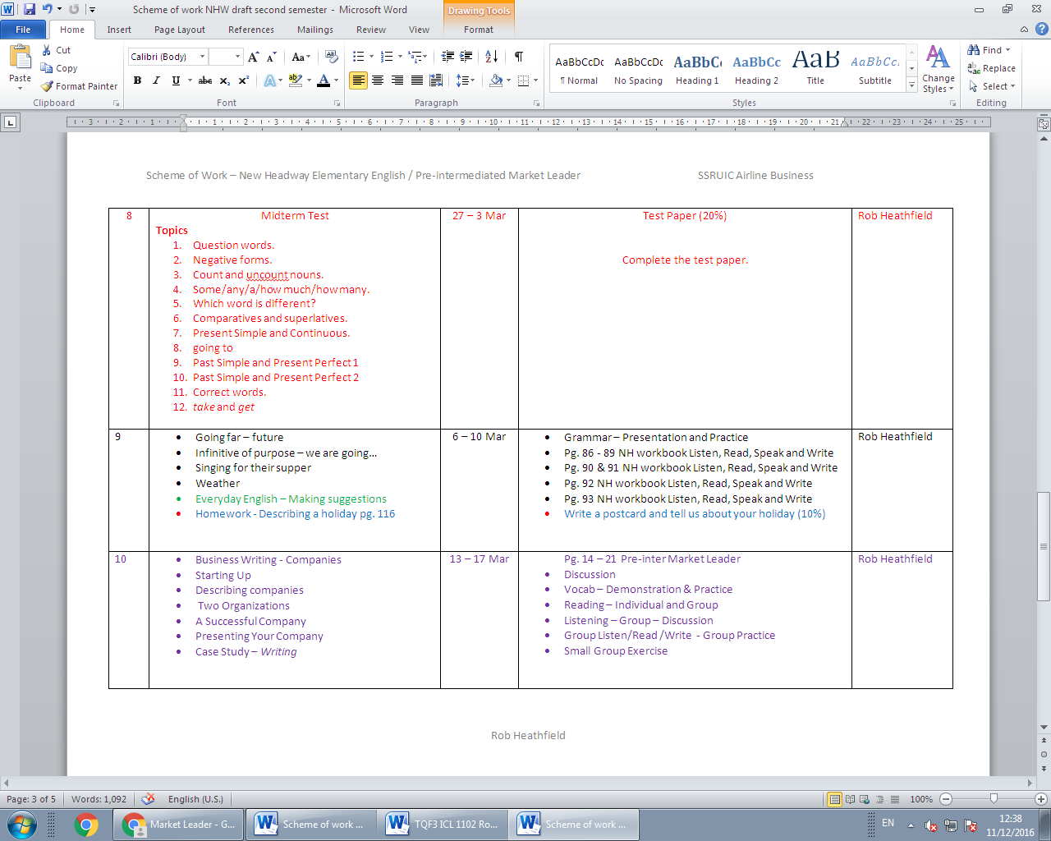

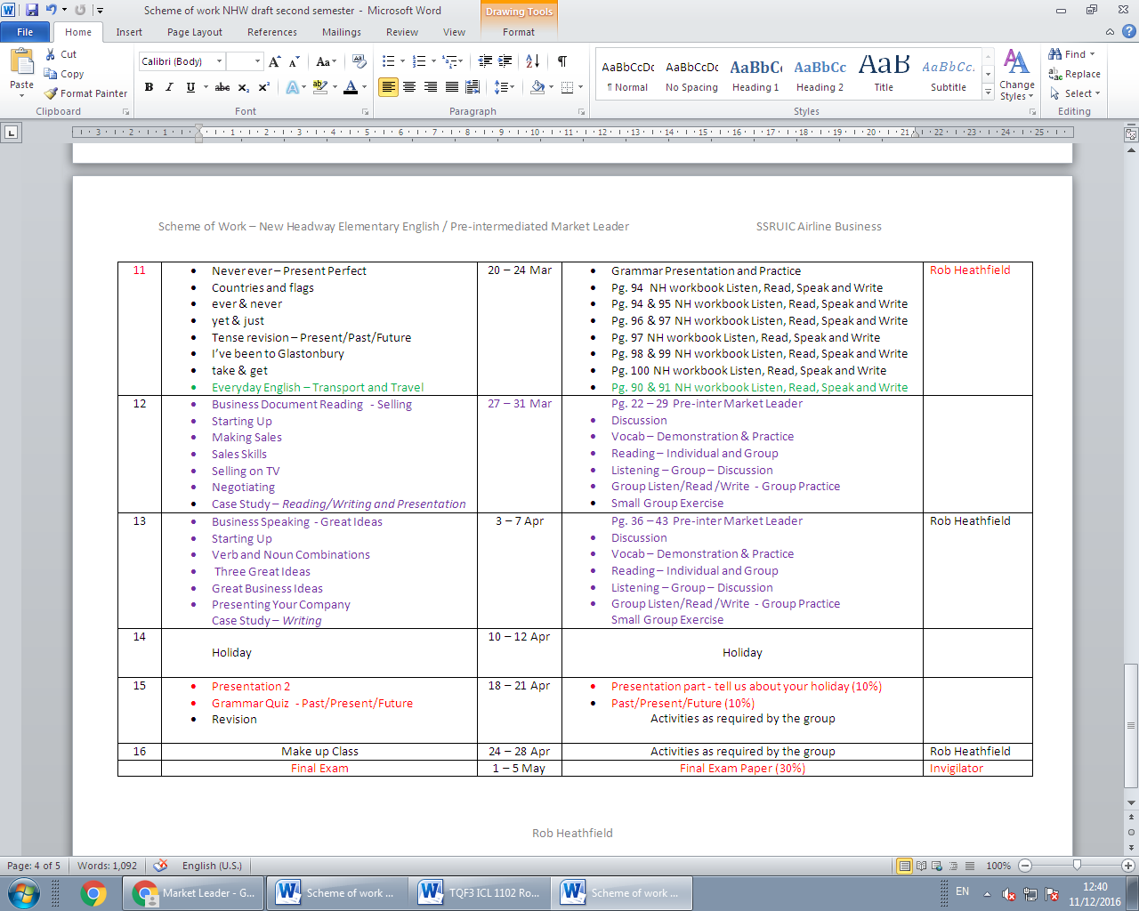

**Section 6 Learning and Teaching Resources**

**1. Textbook and Main Documents**

Pre-intermediate Market Leader Third Edition (2012)

New Headway Elementry Forth Edition (2011) Oxford University Press

**2. Important Documents for Extra Study**

[**www.breakingnewsenglish.com**](http://www.breakingnewsenglish.com)

**3. Suggestion Information (Printing Materials/Website/CD/Others)**

[**https://www.englishclub.com/esl-exams/ets-toeic-practice-4.htm**](https://www.englishclub.com/esl-exams/ets-toeic-practice-4.htm)

[**http://product.pearsonelt.com/marketleader/**](http://product.pearsonelt.com/marketleader/)

[**http://www.examenglish.com/TOEIC/TOEIC_listening_part3.htm**](http://www.examenglish.com/TOEIC/TOEIC_listening_part3.htm)

[**http://www.examenglish.com/TOEIC/TOEIC_listening_part1.htm\**](http://www.examenglish.com/TOEIC/TOEIC_listening_part1.htm\)

**Section 7 Course Evaluation and Revising**

1. **Strategies for Course Evaluation by Students**

Evaluation sheet

Behavior of students in classand uniform standard

Students’ suggestion during the class

1. **Strategies for Course Evaluation by Lecturer**

Exam result and observation

1. **Teaching Revision**

Classroom research

1. **Feedback for Achievement Standards**

Evaluation based on quizzes, paper, presentation, semester paper

1. **Methodology and Planning for Course Review and Improvement**

Encourage the students to do essential and external reading and submit paper and presentation on time. Find further study and information related to this course in library as well as internet

|  |  |  |  |  |  |  |  |  |  |  |  |  |  |  |  |  |  |  |  |
| --- | --- | --- | --- | --- | --- | --- | --- | --- | --- | --- | --- | --- | --- | --- | --- | --- | --- | --- | --- |
| Courses | 1. Morals and Ethics | | | 2. Knowledge | | | 3. Cognitive Skills | | | 4. Interpersonal Skills  and Responsibility | | | | 5. Numerical Analysis, Communication and Information Technology  Skills | | | 6.Other Domain ie.Learning Management Skills | | |
| Course Category : Required Course | **● Major Responsibility ○ Minor Responsibility** | | | | | | | | | | | | | | | | | | |
| **1** | **2** | **3** | **1** | **2** | **3** | **1** | **2** | **3** | | **1** | **2** | **3** | **1** | **2** | **3** | **1** | **2** | **3** |
| Course ICL1101  Course Title : English for Communication and Study Skills | **●** | **●** | **●** | **●** | **●** | **●** | **●** | **●** | **●** | | **●** | **●** | **●** | **●** | **○** | **●** |  |  |  |

**Curriculum Mapping Illustrating the Distribution of Program Standard Learning Outcomes to Course Level**